SIA 102 UI Final - Functional Explanation per UI
This document explains the function of each UI tab based on system workflow. Each section includes exactly four sentences.

Admin Revenue Analytics Dashboard
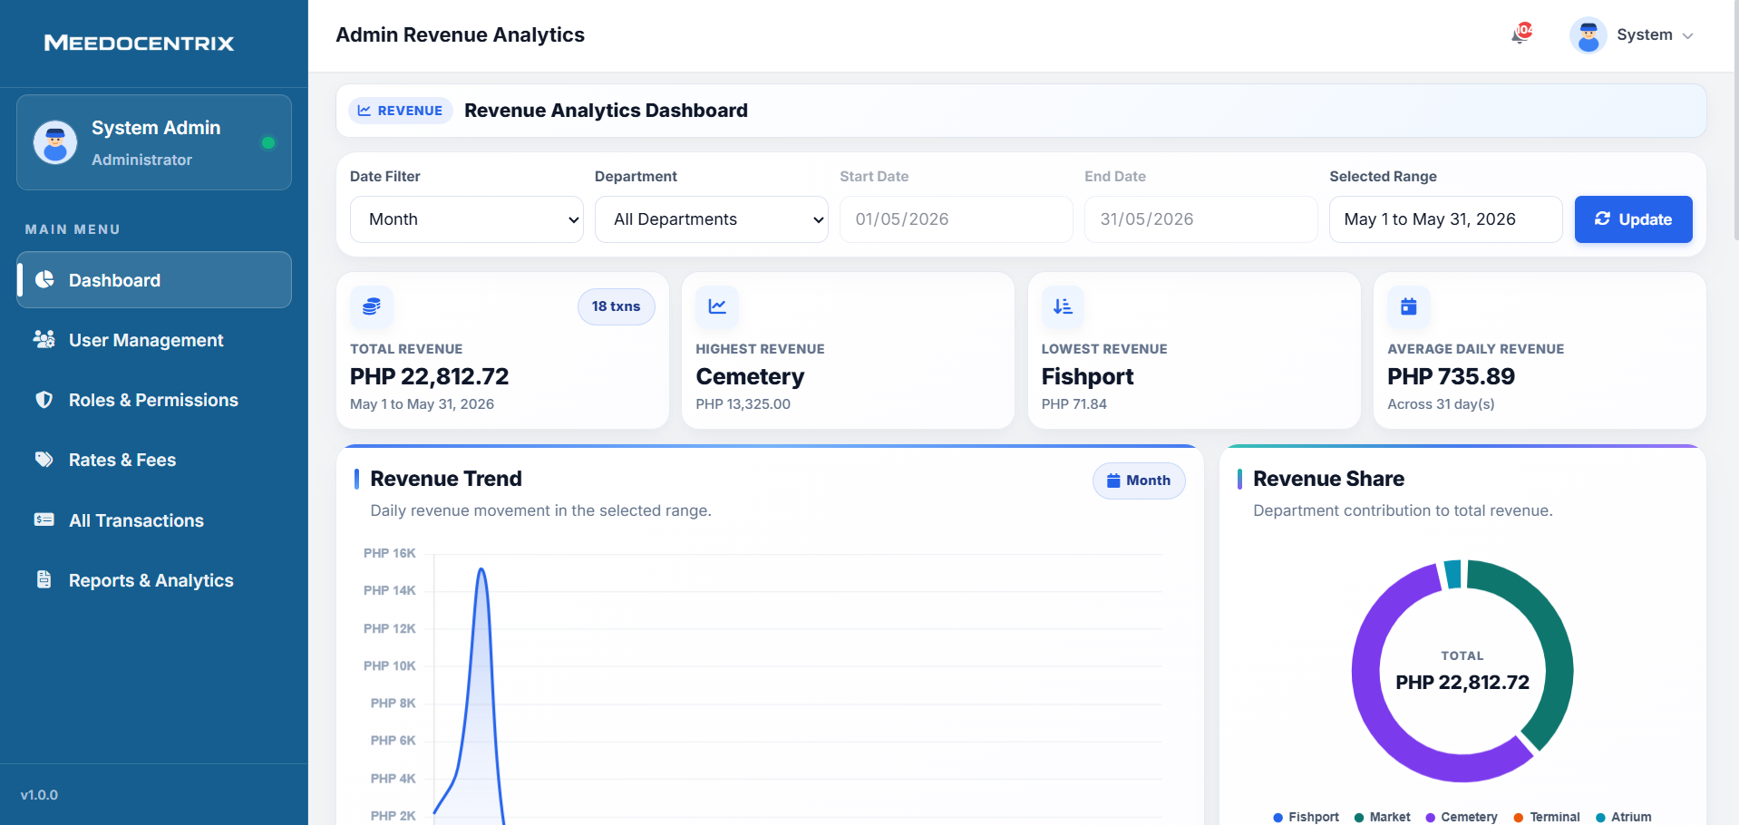
This tab is the central monitoring area where the System Admin tracks total revenue across all departments in one view. It lets the admin apply date and department filters so decisions are based on the exact reporting period needed. The cards and trend charts help identify which unit has the highest and lowest collections and whether income is increasing or declining. In daily operations, this UI is used to validate financial performance quickly before adjusting rates, staffing, or follow-up priorities.
Admin Rates and Fees Control
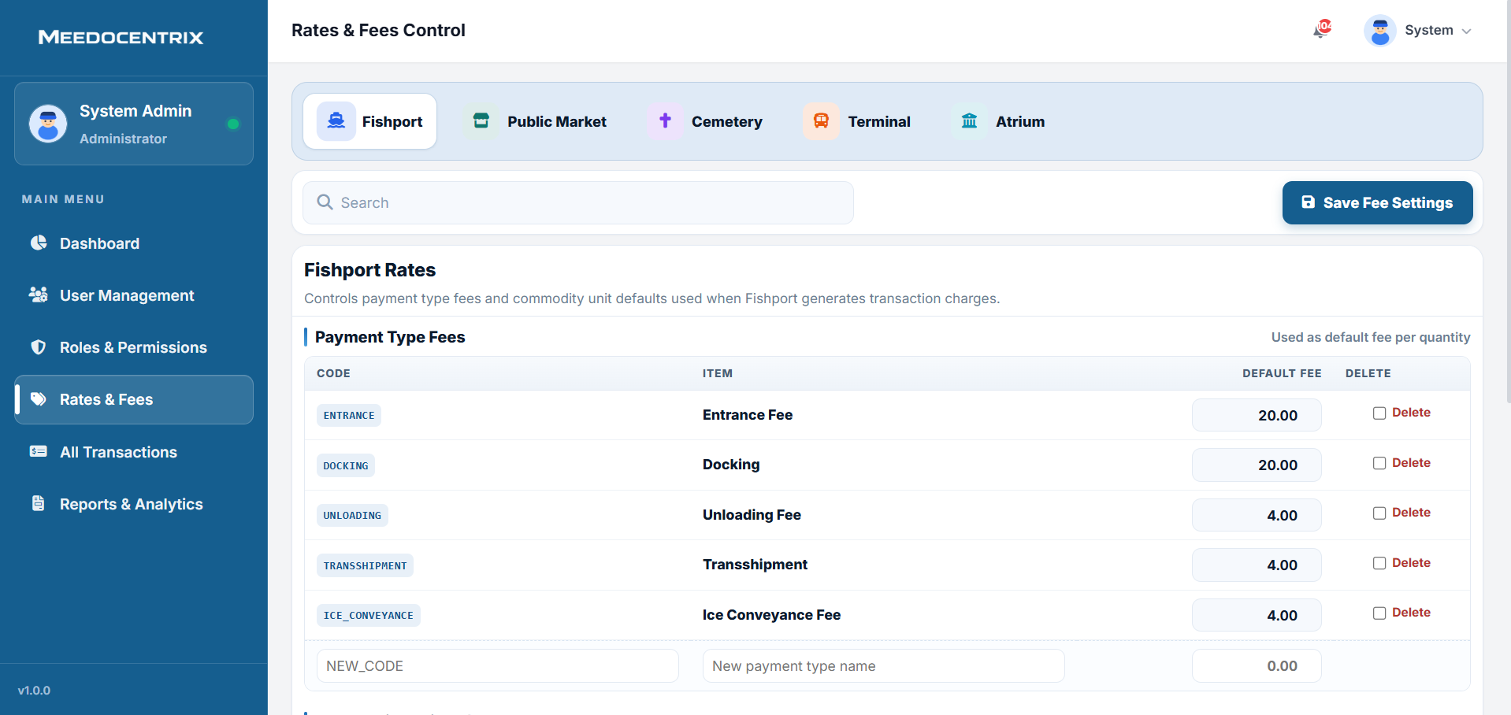
This tab configures default service fees used by each department when transactions are generated. The admin can switch department contexts, edit fee amounts, add new fee codes, and save updated billing rules. It acts as the pricing source of truth so charges stay standardized across front-line users and collectors. Operationally, this UI prevents inconsistent billing and keeps revenue computation aligned with approved policies.
Admin Reports and Analytics
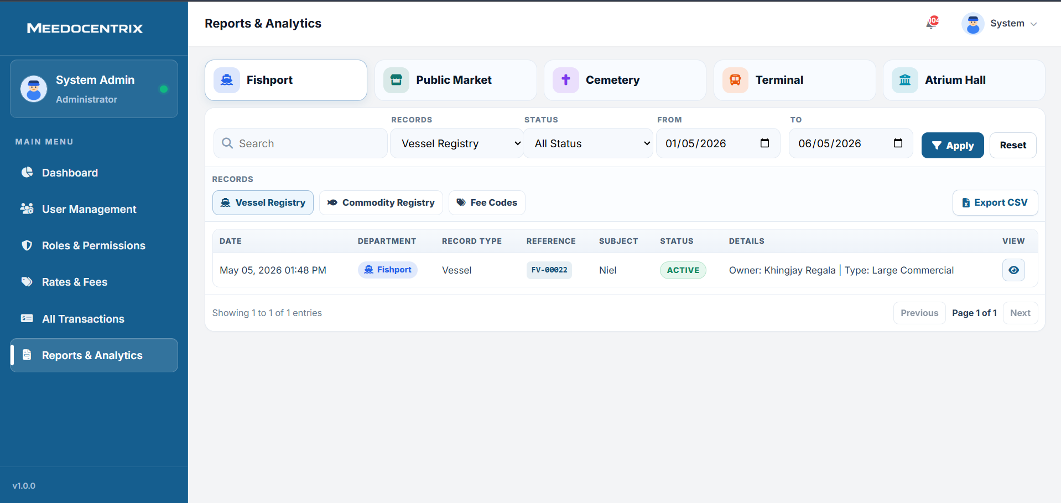
This tab generates structured reports from selected departments and record types using date and status filters. It supports focused reporting views such as registries, fee codes, and operational records for deeper analysis. Users can export data to CSV after applying filters, which helps with monthly consolidation and documentation. Functionally, this UI converts raw transactional activity into report-ready output for management and audit use.
Admin Roles and Permissions
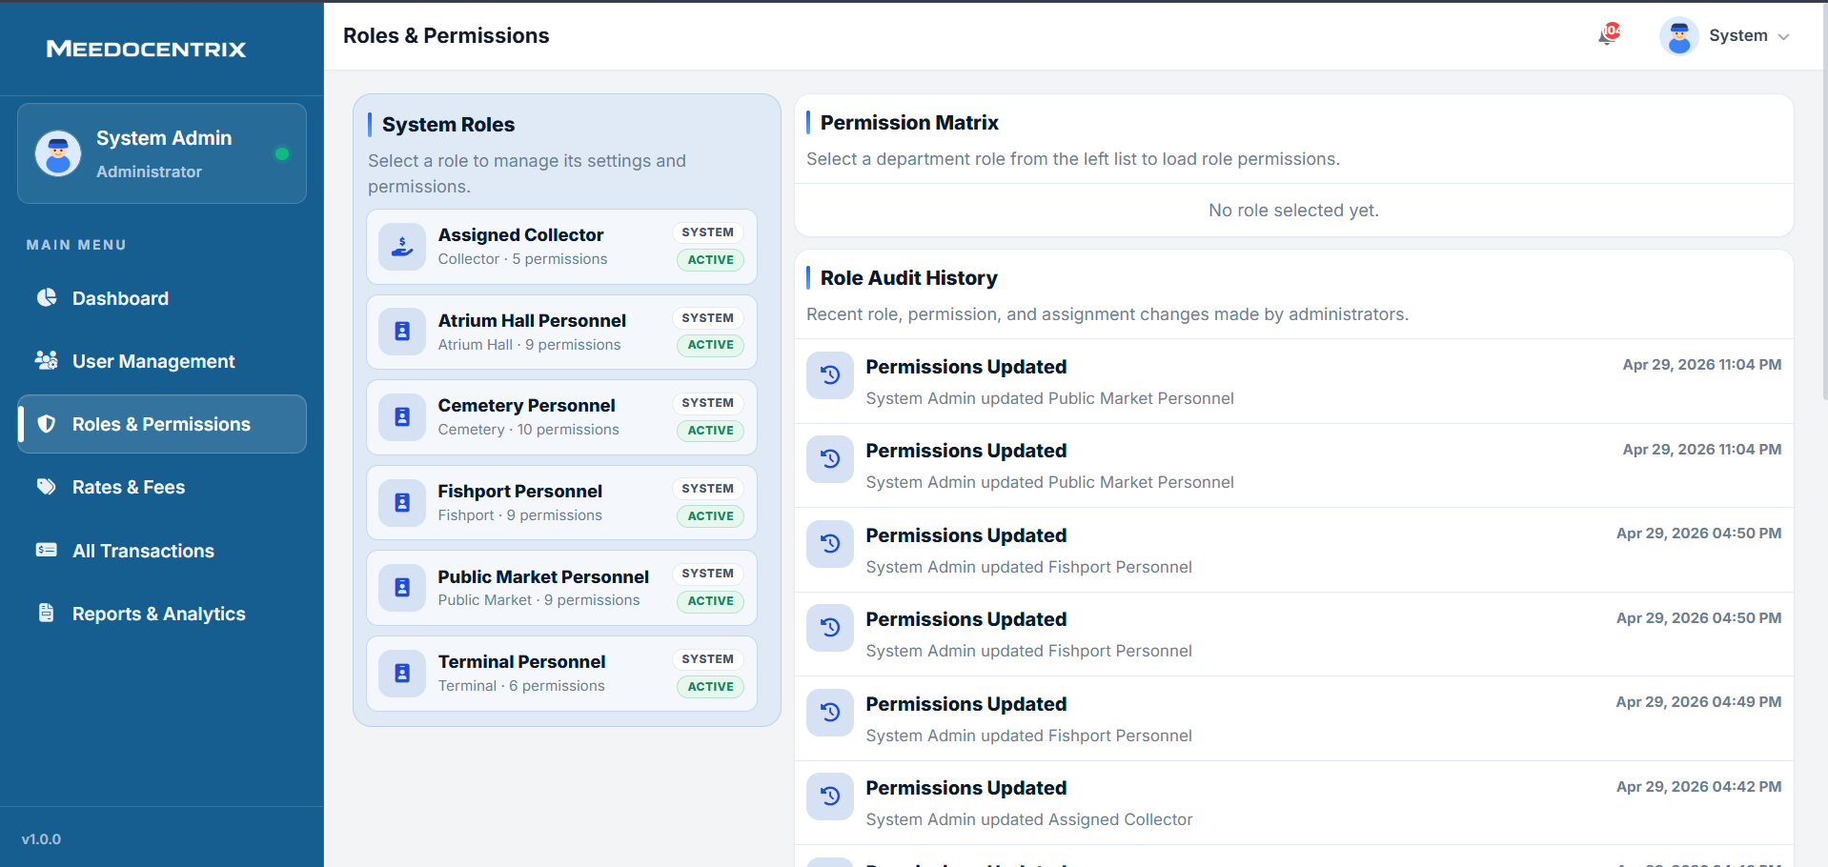
This tab defines what each system role is allowed to view, create, edit, approve, or delete inside the platform. The permission matrix section is used to load a role and apply precise module-level privileges per department. The audit history panel records permission changes so accountability is preserved for security and compliance checks. In practice, this UI ensures users only perform actions aligned with their official responsibilities.
Admin All Transactions Ledger
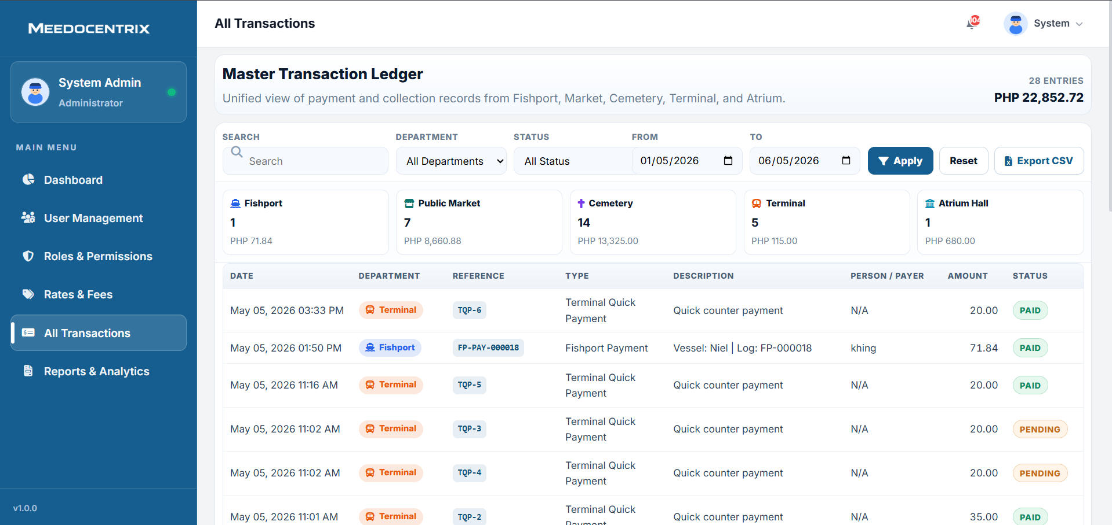
This tab is a master ledger that consolidates transactions from Fishport, Public Market, Cemetery, Terminal, and Atrium. It allows filtering by department, status, and date range to audit payment activity with precision. The export action is used to download filtered records for reconciliation, review, or external reporting needs. In system workflow, this UI is the primary control point for cross-department verification and dispute checking.
Admin User Management
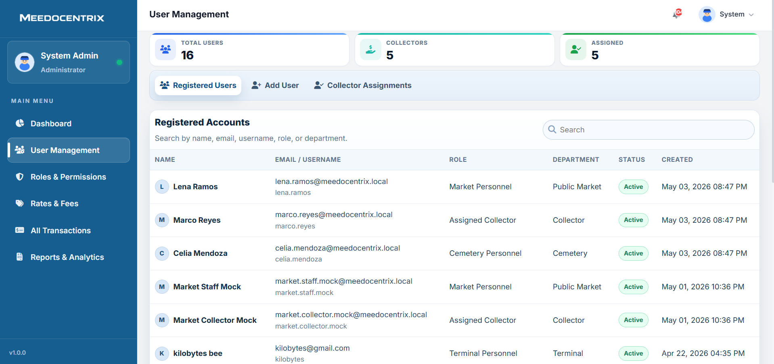
This tab manages user lifecycle tasks such as viewing registered accounts, adding new users, and assigning collectors to departments. It provides searchable user records with role, department, and status so access can be controlled consistently. The admin uses this screen to keep account ownership clean and ensure each department has the correct personnel assigned. Functionally, it protects system governance by reducing unauthorized access and preventing role confusion during operations.
Atrium Payments
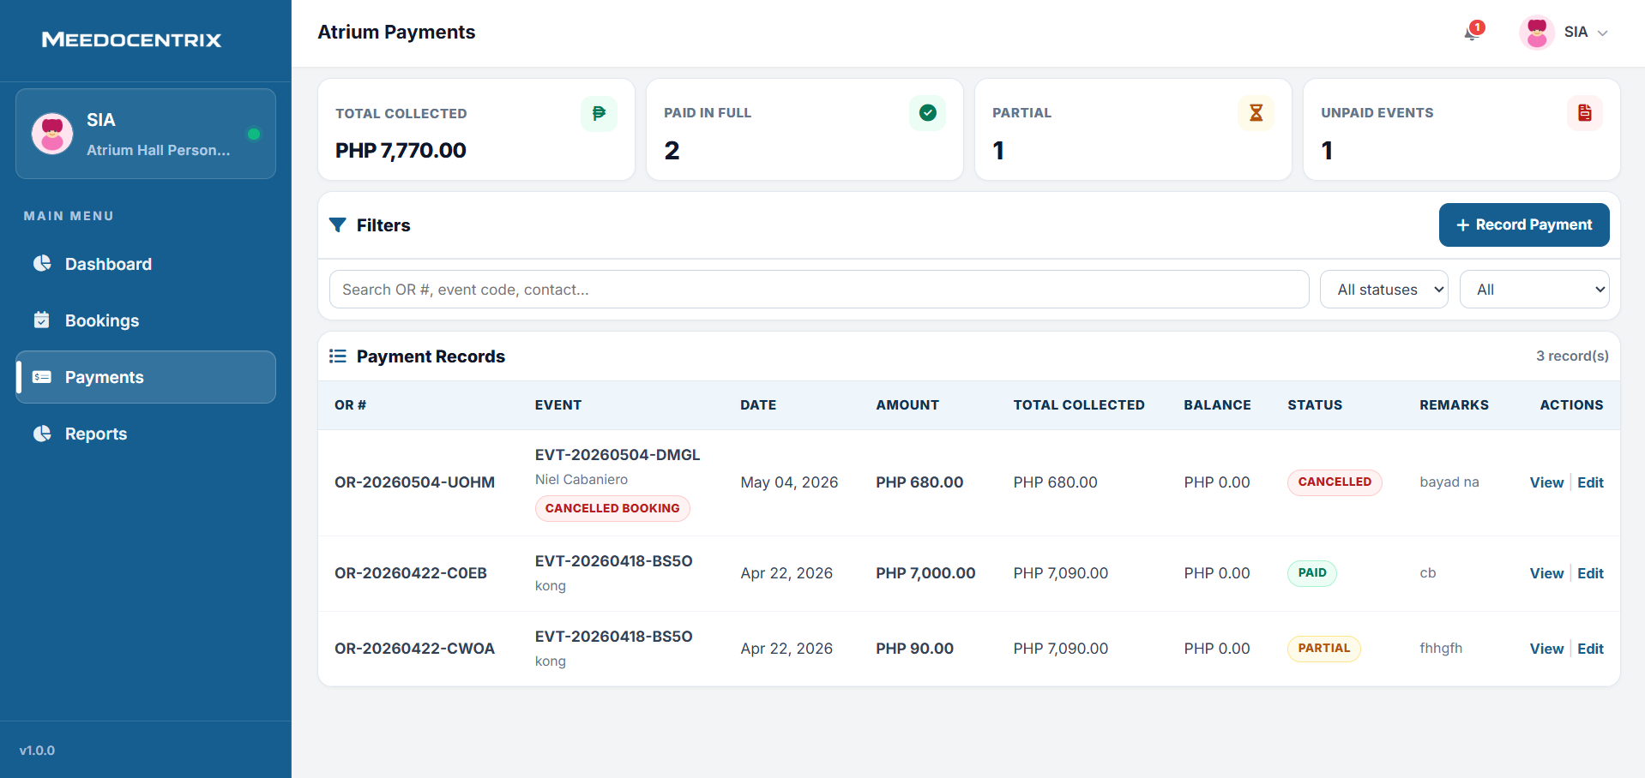
This tab records Atrium payment transactions and tracks whether events are paid in full, partial, or still unpaid. The record payment action is used to post incoming amounts and update running balance values. Search and status filters allow quick audit of official receipt references and linked events. In finance flow, this UI is the core register for validating event collections and remaining balances.
Atrium Bookings
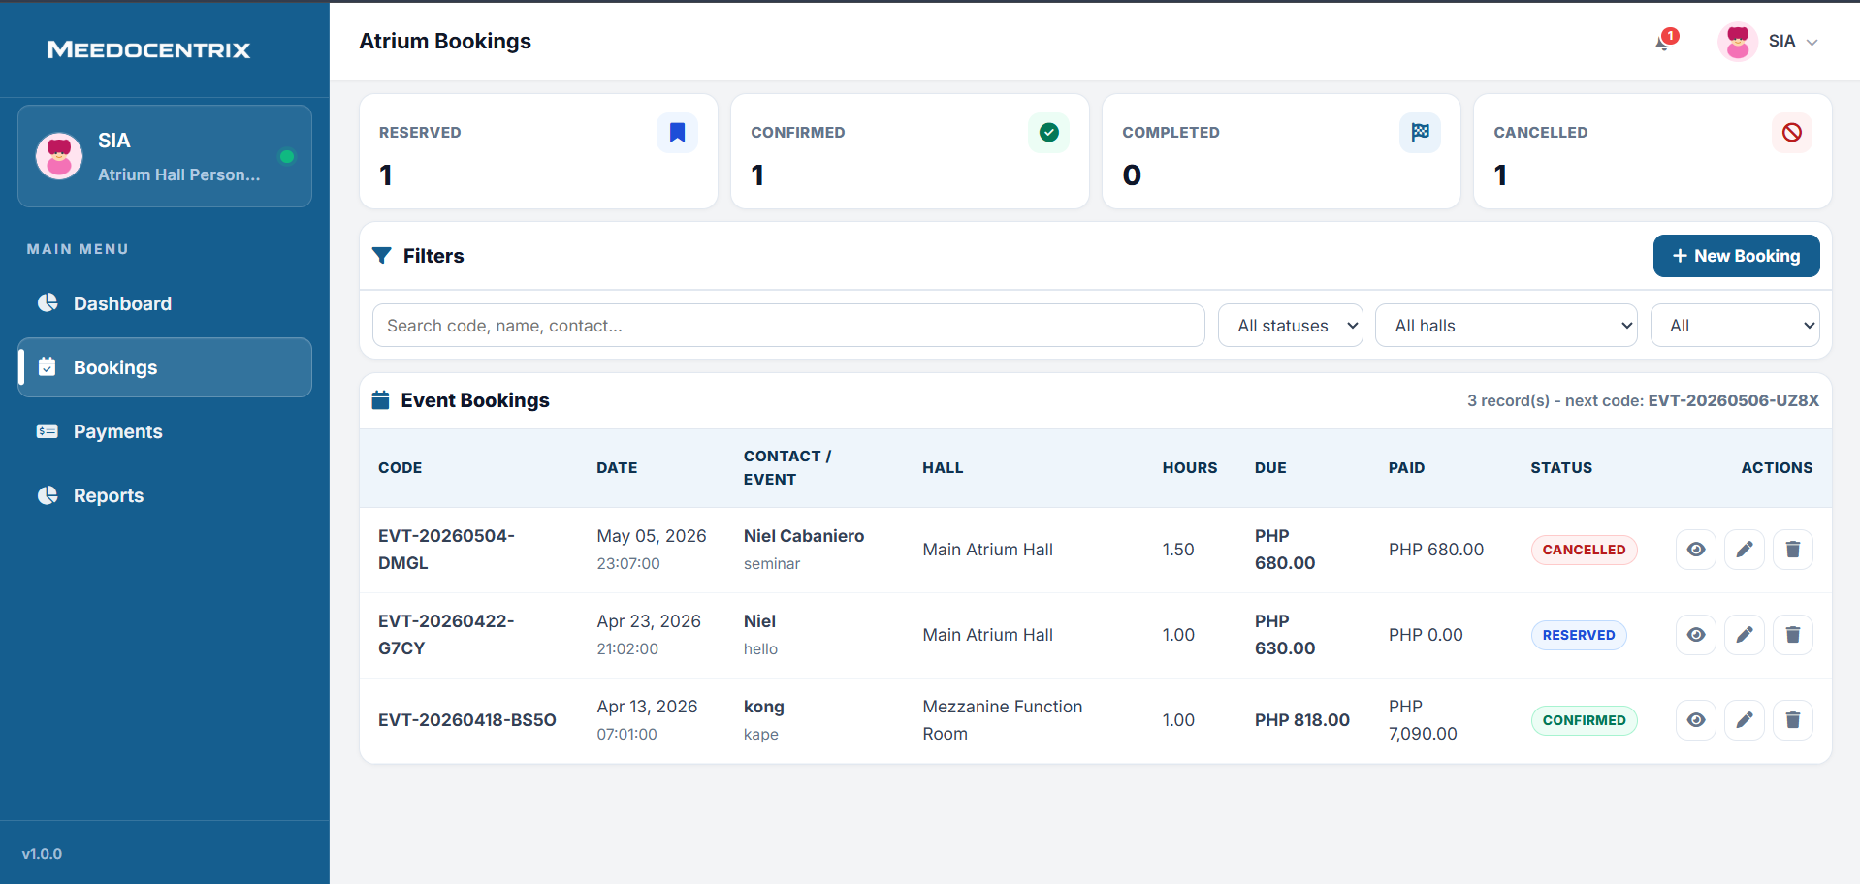
This tab handles event reservation records, including booking status, hall assignment, event duration, and due amounts. Filter controls and search tools help staff locate customer records and manage active reservations efficiently. The new booking action is used to register additional events while keeping sequence codes and status transitions consistent. Functionally, this UI drives the full booking lifecycle from reservation to completion or cancellation.
Atrium Dashboard
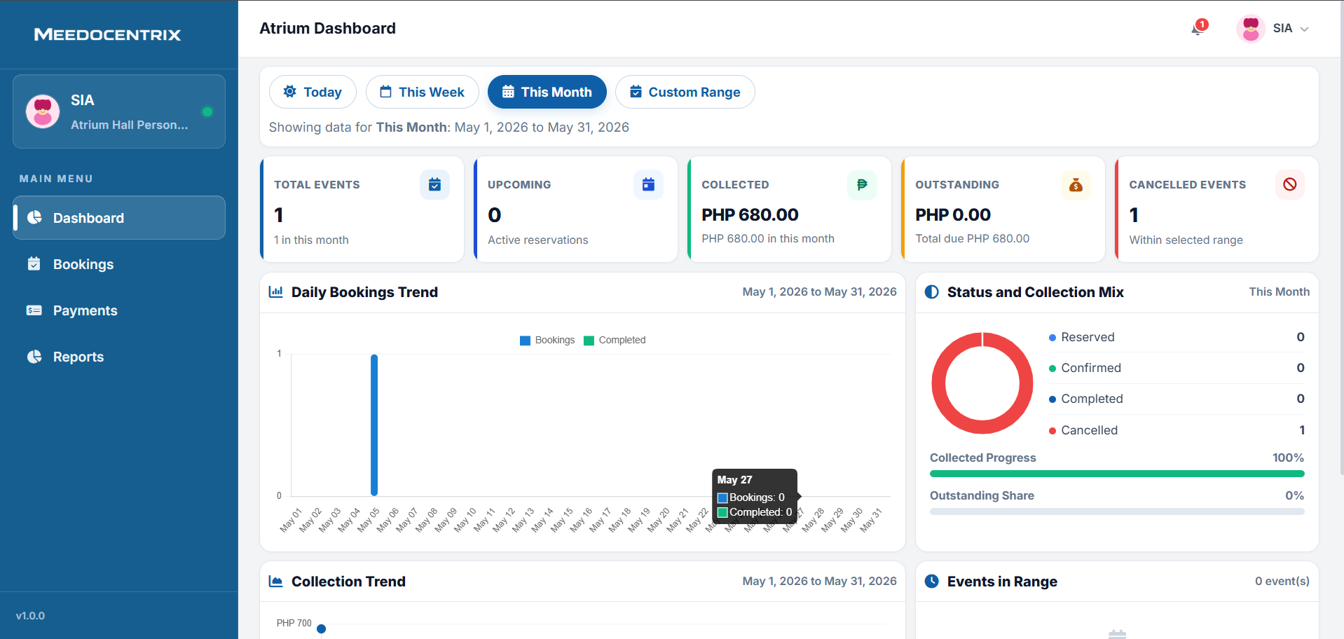
This dashboard provides Atrium Hall personnel with booking, collection, outstanding, and cancellation indicators in a single control view. Period filters support monitoring performance for day, week, month, or custom date ranges. Trend and mix panels show event activity and collection progress so staff can spot weak follow-through quickly. In real workflow, this UI is the planning board before booking updates, payment posting, or report generation.
Atrium Reports
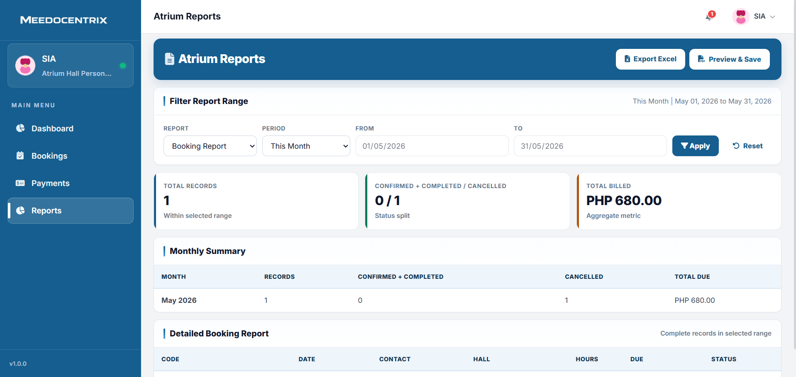
This tab creates booking and billing reports for Atrium operations within the selected report period. It combines summary counters with monthly and detailed tables to support both quick and deep analysis. Export and preview features provide convenient outputs for stakeholders and periodic filing. Functionally, this UI transforms booking and payment data into formal decision-support and audit-ready reports.
Cemetery Transactions
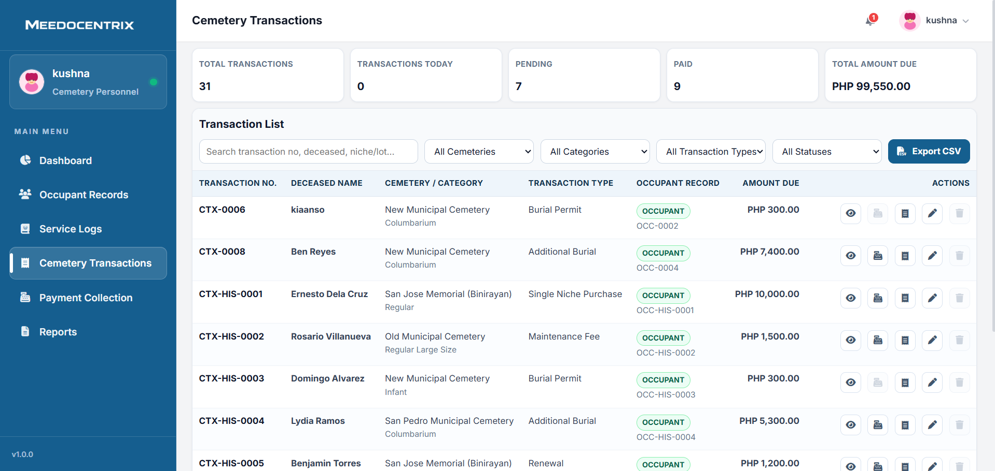
This tab manages cemetery billing records connected to occupant services and maintenance-related charges. Search and filter controls let staff isolate transactions by cemetery, category, type, and payment status for processing. Row-level actions support viewing, receiving payment, printing, editing, and lifecycle management of each charge item. Functionally, this UI is the payment-ready ledger that links service execution to collectible revenue.
Cemetery Service Logs
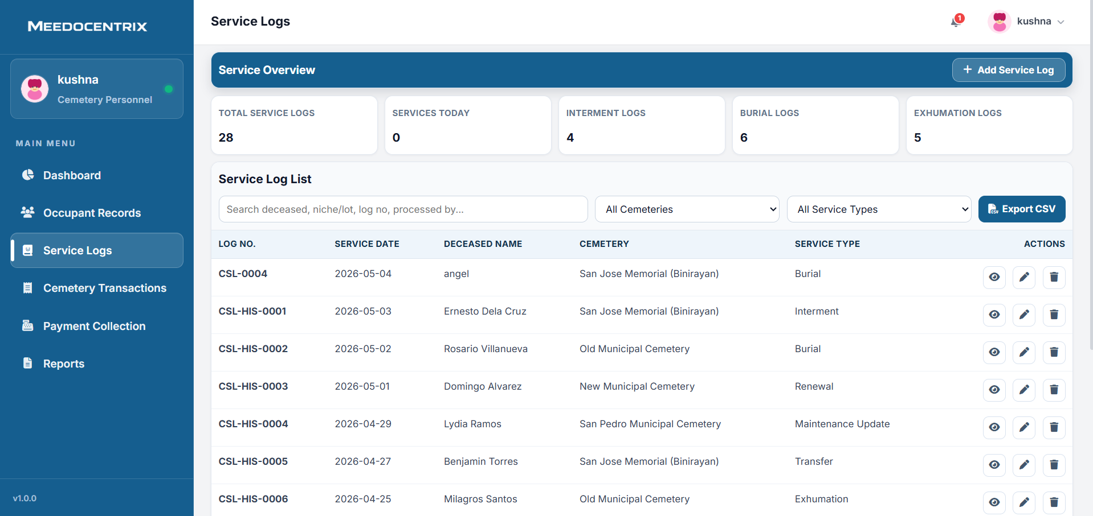
This tab logs cemetery service activities such as interment, burial, transfer, exhumation, and maintenance updates. It includes operational counters and filter tools so staff can monitor service volume and locate specific records fast. New service entries can be added and existing entries can be reviewed or corrected through row actions. In process flow, this UI preserves service history that supports both legal documentation and related transaction generation.
Cemetery Occupant Records
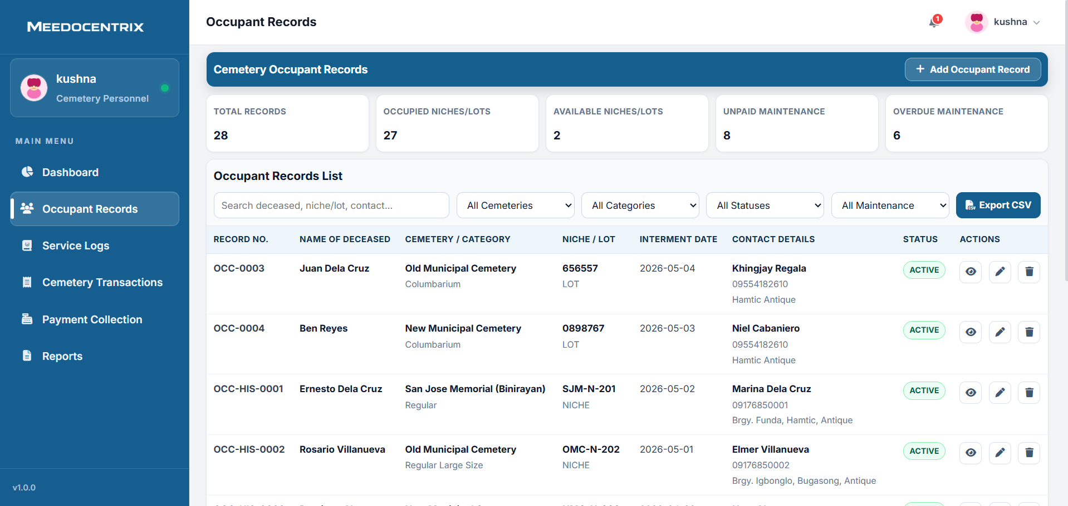
This tab is the master registry for deceased occupant records, niche or lot assignment, and contact ownership details. Filters help users narrow records by cemetery, category, payment condition, and active status. Action buttons allow staff to view, update, or maintain each record while keeping historical identifiers intact. Functionally, this UI safeguards long-term memorial data integrity and supports accurate billing references.
Cemetery Payment Collection
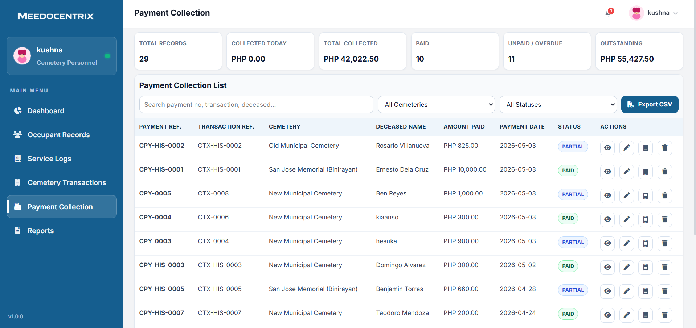
This tab tracks actual payment receipts for cemetery transactions, including fully paid and partial payment outcomes. The top metrics show collected totals, outstanding balances, and unpaid or overdue exposure for immediate monitoring. Staff can search payment references, open record actions, and export the collection list for reconciliation. In operations, this UI provides the clearest view of cash recovery progress against cemetery obligations.
Cemetery Dashboard
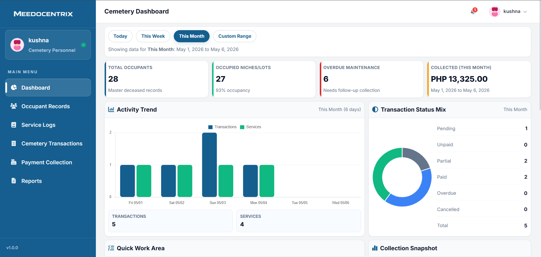
This dashboard summarizes cemetery operations through occupant counts, occupied lots, overdue maintenance, and collected totals. Date controls allow the team to switch reporting windows and track activity changes over time. Status-mix and trend components reveal how many transactions are pending, paid, partial, overdue, or cancelled. In routine operations, this UI is used to prioritize follow-up and plan service or collection actions.
Cemetery Reports
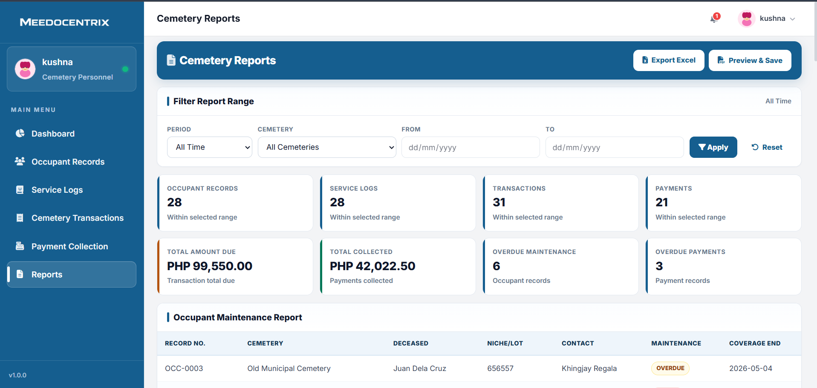
This tab consolidates cemetery analytics across occupant records, service logs, transactions, and payment collections. Users can set report scope by period and cemetery to generate focused compliance or management summaries. Key financial and operational counters are presented before detailed report tables for faster interpretation. Functionally, this UI is used to produce accountable documentation for cemetery administration and financial oversight.
Collector Reports
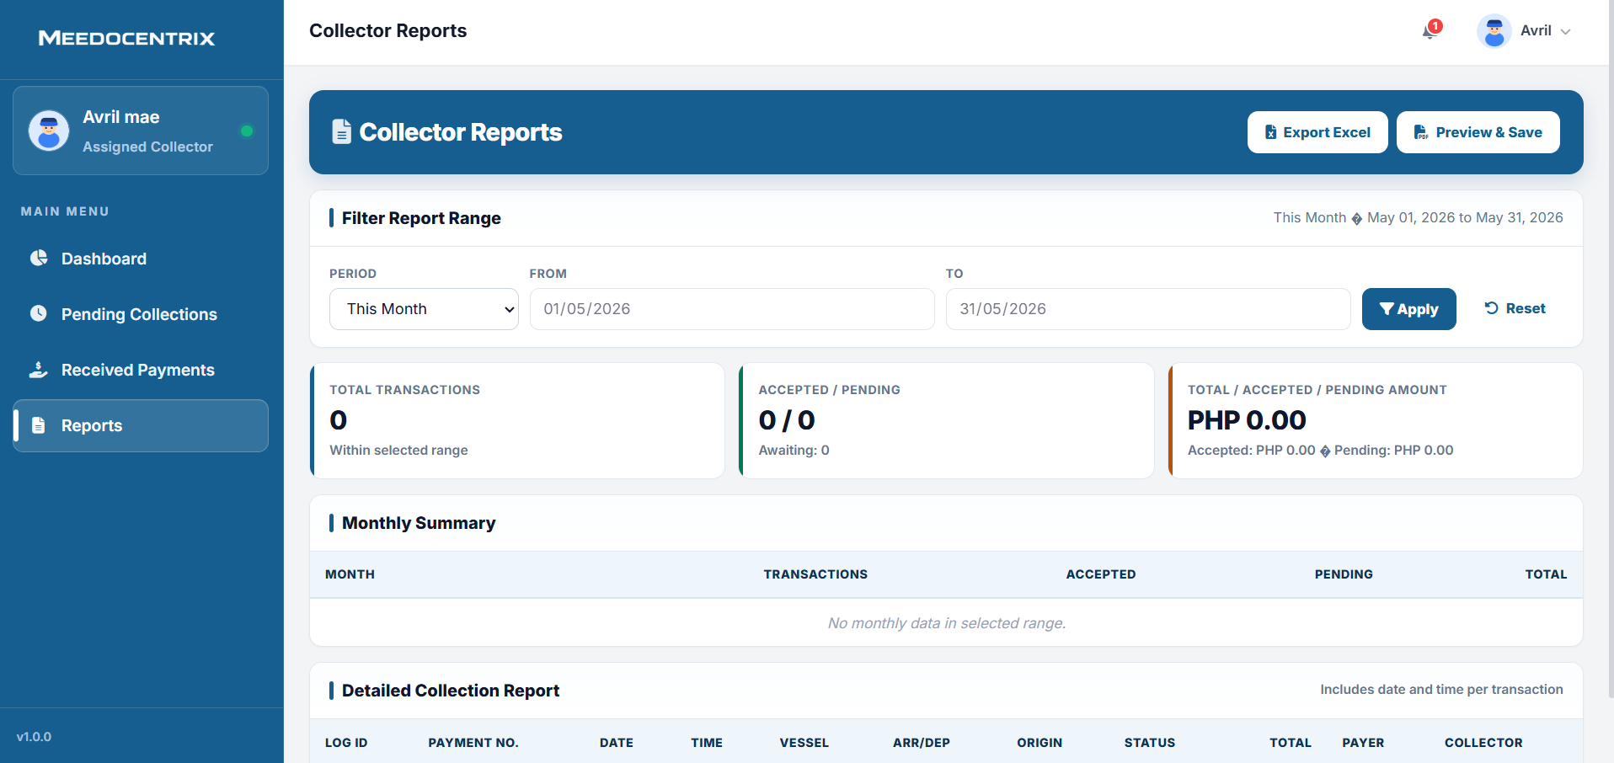
This tab generates collector-level summaries for the chosen date range, including totals, status counts, and value breakdowns. It offers export and preview tools so reports can be submitted to supervisors or attached to periodic compliance files. Monthly and detailed sections provide both snapshot metrics and transaction-level transparency. Functionally, this UI turns collection activity into auditable performance and accountability reports.
Collector Dashboard
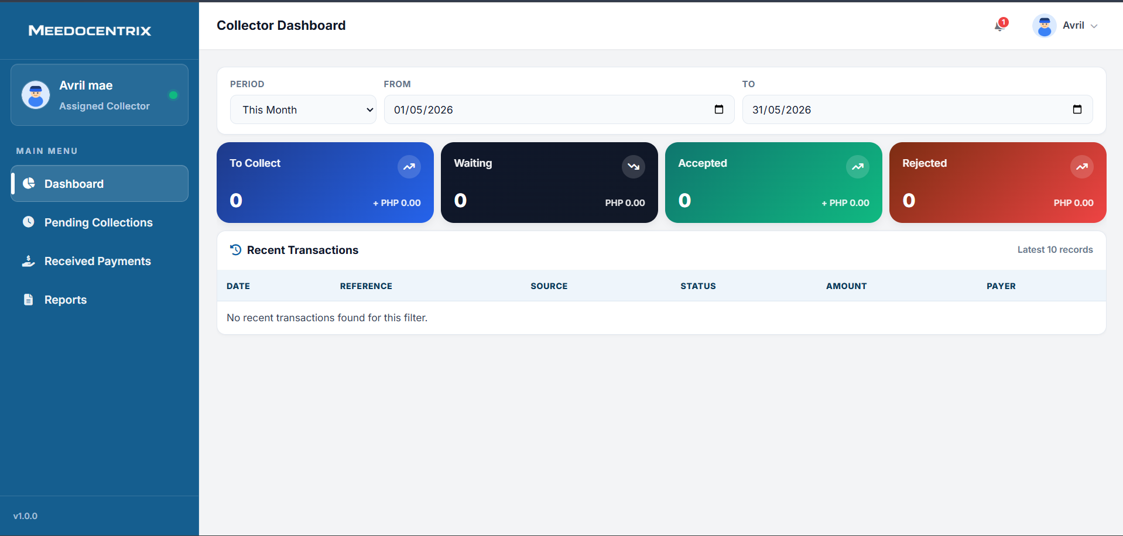
This dashboard gives an assigned collector a quick view of current workload and collection outcomes in the selected period. It separates values into to-collect, waiting, accepted, and rejected so the collector can prioritize actions. Recent transactions are shown as a short operational log for immediate status awareness. In practical workflow, this screen is the collector's starting point before opening pending collections or payment review tasks.
Collector Pending Collections
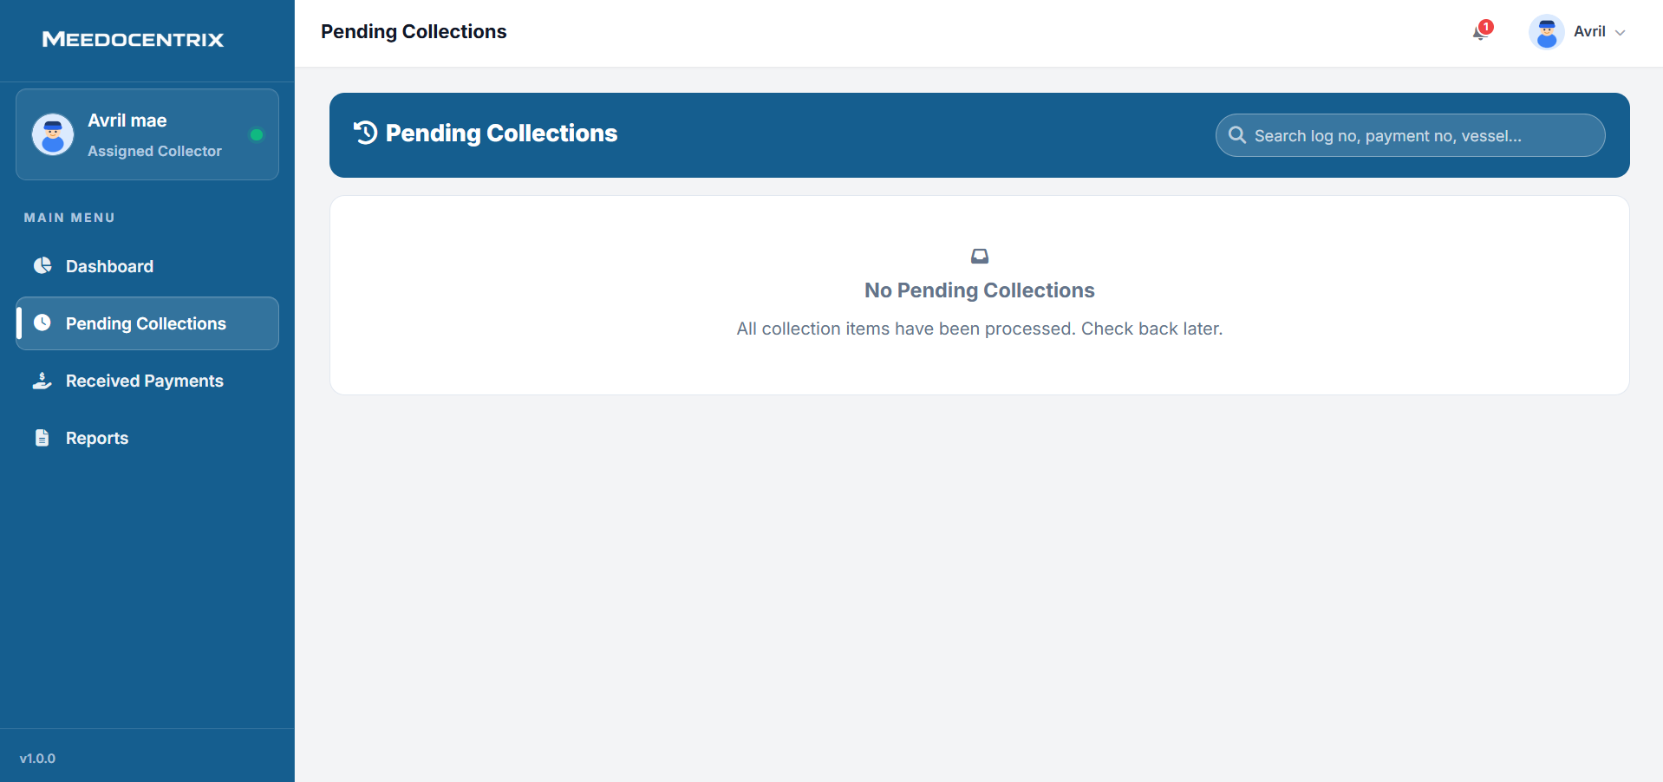
This tab lists collection items that are waiting for the collector to process in the field or counter workflow. The search bar helps locate specific logs, payment numbers, or vessels when the queue is large. When no items are available, it clearly indicates that all collection tasks are already processed for the moment. Functionally, this UI keeps collectors focused on outstanding work and prevents missed collection assignments.
Collector Received Payments
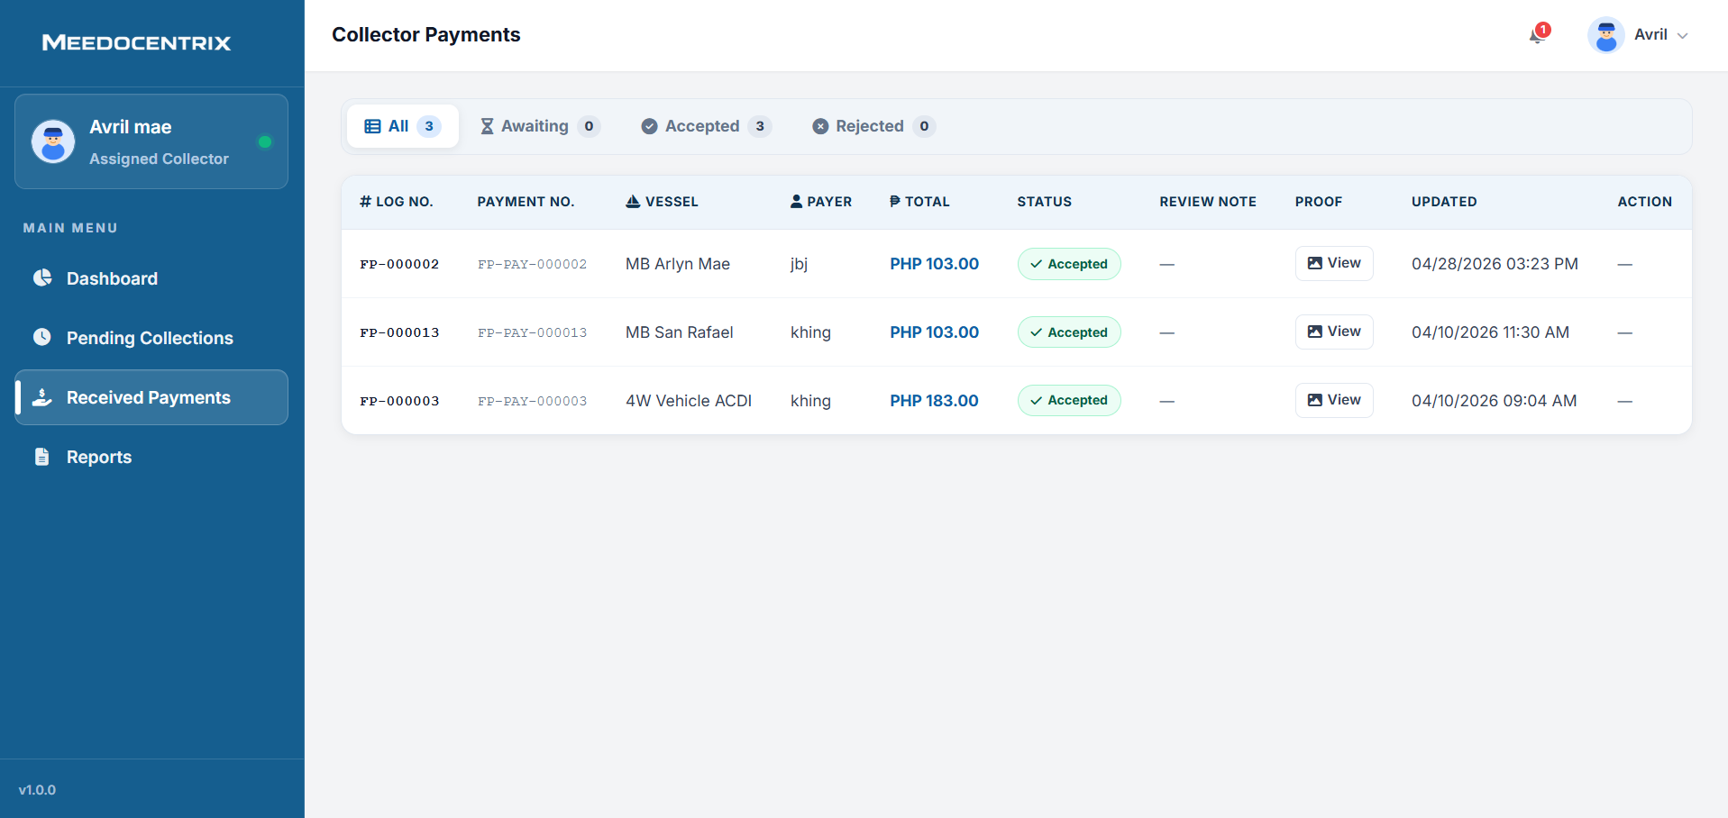
This tab records and reviews payments that have been submitted to the collector, including proof and status outcomes. Filter chips separate all, awaiting, accepted, and rejected entries for faster payment validation. The table provides traceable links between log number, payment number, payer, total amount, and update timestamp. In operations, this UI is used to confirm accepted collections and maintain clean evidence trails for approvals.
Terminal Dashboard
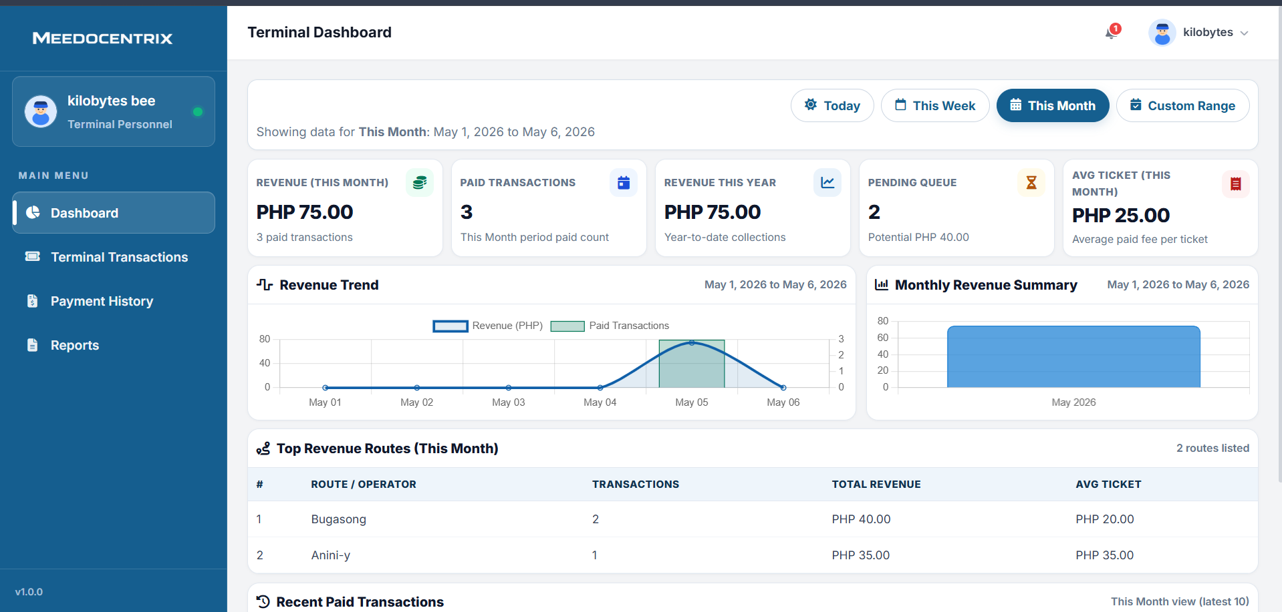
This dashboard summarizes terminal revenue activity, including paid count, pending queue, average ticket value, and period totals. Time-range tabs allow staff to evaluate short-term and month-level trends without leaving the screen. Revenue charts and route summaries make it easier to identify high-performing operators and weak collection periods. In operational use, this UI is the terminal team's command center before updating transactions or reviewing payment history.
Terminal Payment History
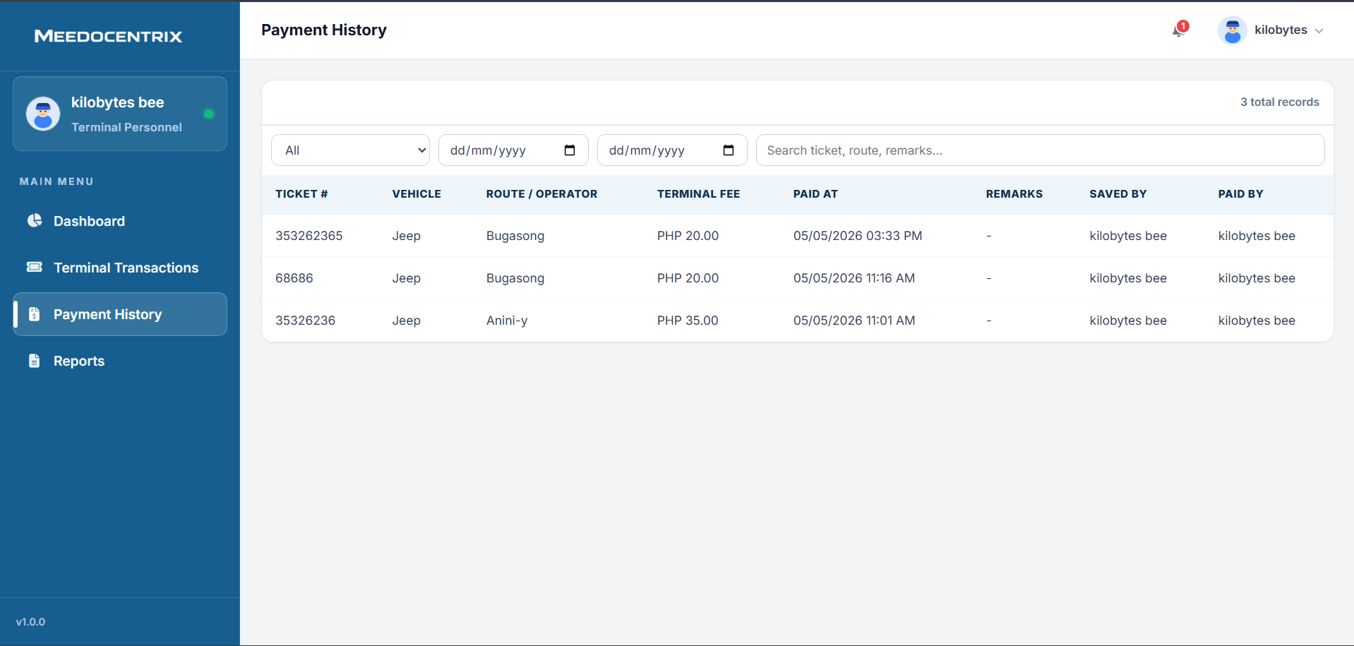
This tab stores completed terminal payment records for auditing and historical lookup. It captures ticket number, route or operator, terminal fee, payment timestamp, and user accountability fields. Date and keyword filters help staff retrieve exact transactions for verification or inquiry resolution. In workflow terms, this UI is the finalized payment archive after collection is posted.
Terminal Transactions
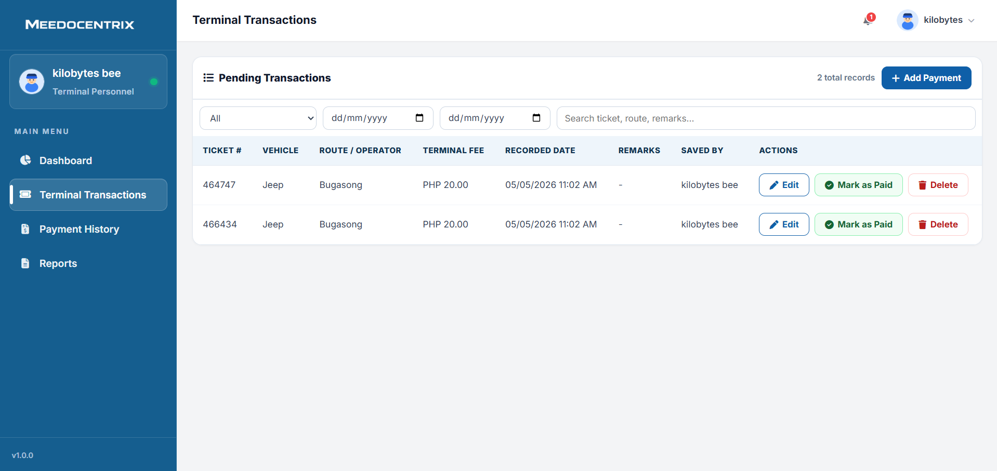
This tab manages pending terminal ticket charges before they are finalized as paid records. Staff can filter by date and search terms, then edit entries, mark transactions as paid, or remove invalid records. The add payment action supports fast manual entry when new ticket charges are received on-site. Functionally, this UI controls the pre-settlement stage of terminal revenue processing.
Terminal Reports
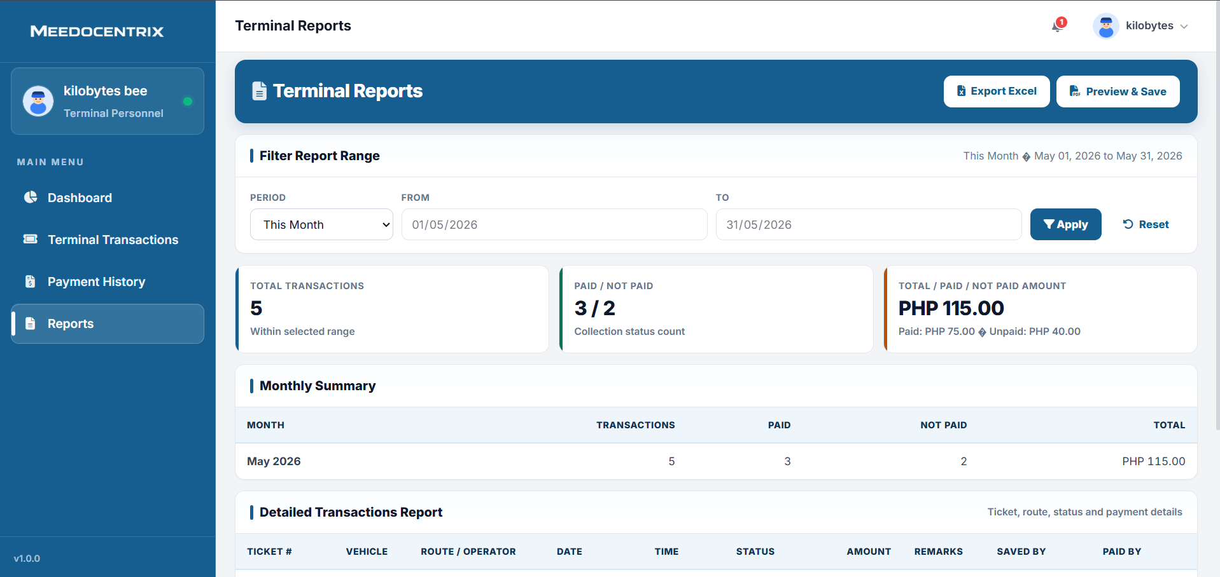
This tab generates terminal performance reports using selected period filters and exports. Summary cards present transaction volume, paid-versus-unpaid count, and value totals before detailed record analysis. Monthly and detailed report sections provide both managerial overview and row-level audit transparency. Functionally, this UI supports revenue review, compliance reporting, and operational planning for terminal services.
Fishport Dashboard
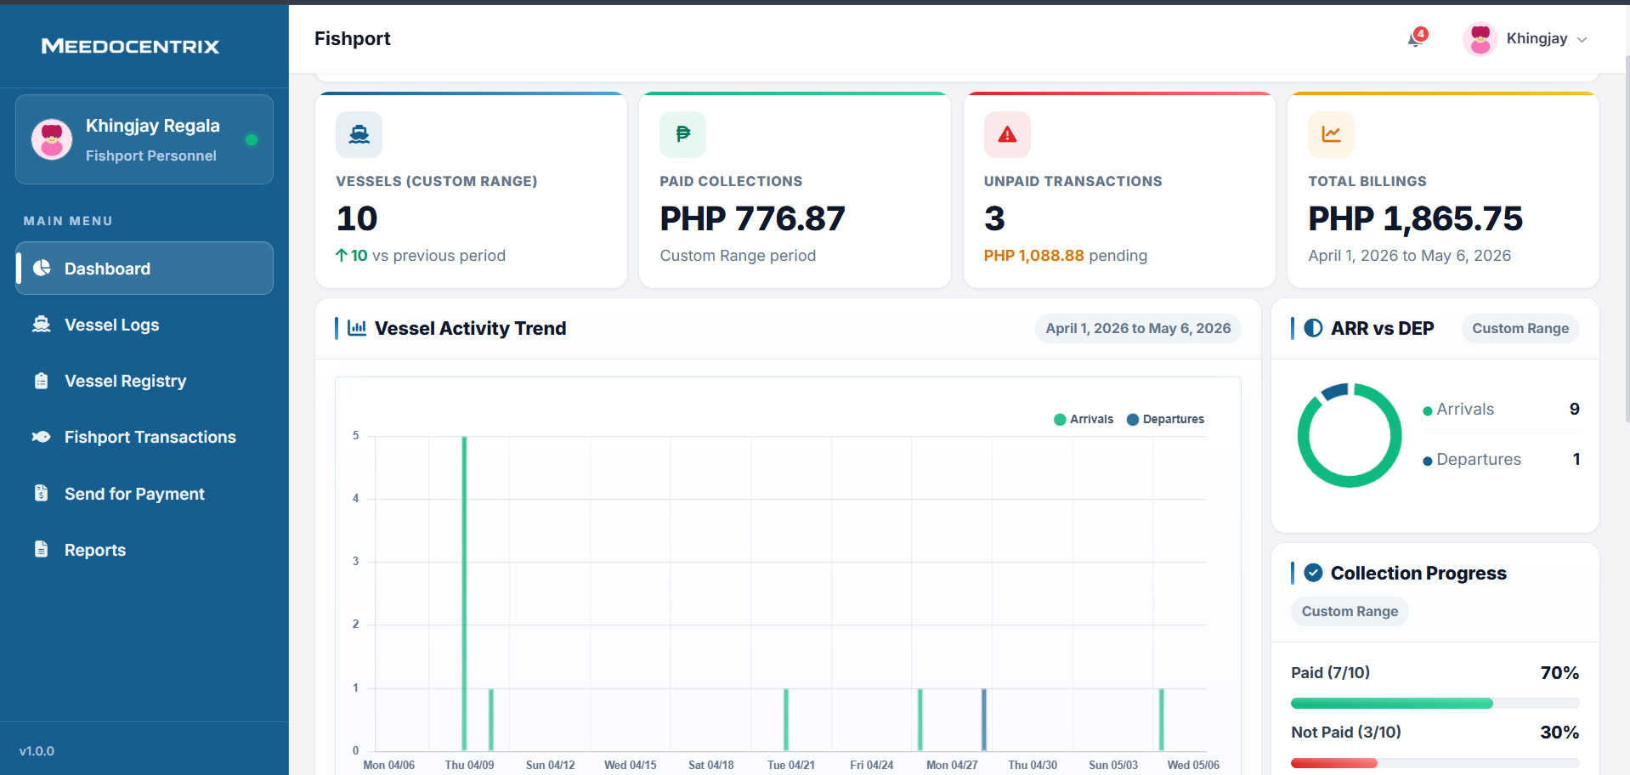
This dashboard is the primary operational summary for Fishport, covering vessel count, paid collections, unpaid transactions, and total billings. Time filters allow staff to compare activity across custom ranges and monitor route traffic patterns. Trend, arrival-versus-departure, and collection-progress panels help identify where billing follow-up is needed. In day-to-day work, this UI guides the team before logging vessels, posting transactions, or dispatching unpaid items.
Fishport Send for Payment
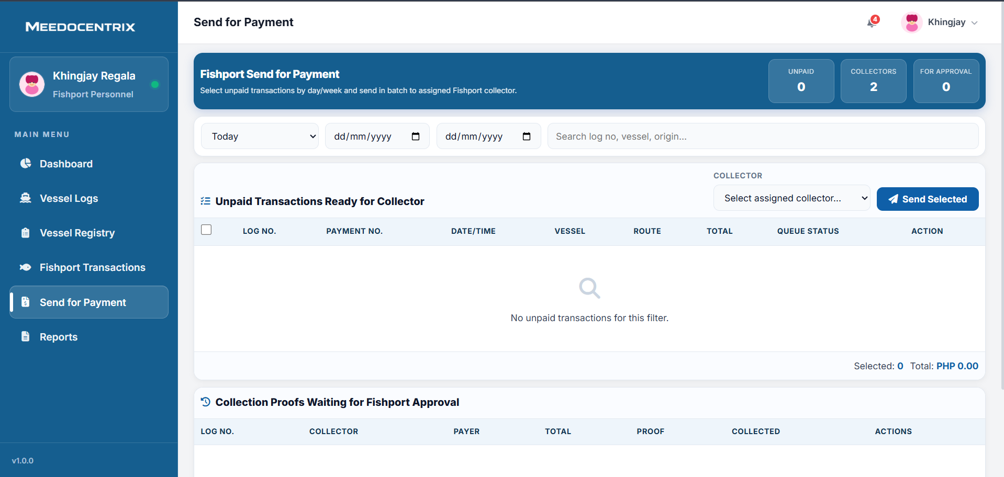
This tab sends unpaid Fishport transactions to assigned collectors in a controlled batch workflow. Staff can filter unpaid records, select target entries, choose a collector, and dispatch the selected queue in one action. A secondary section tracks collection proofs waiting for Fishport approval before status finalization. In operational terms, this UI is the core handoff and approval checkpoint for unpaid Fishport collections.
Fishport Reports
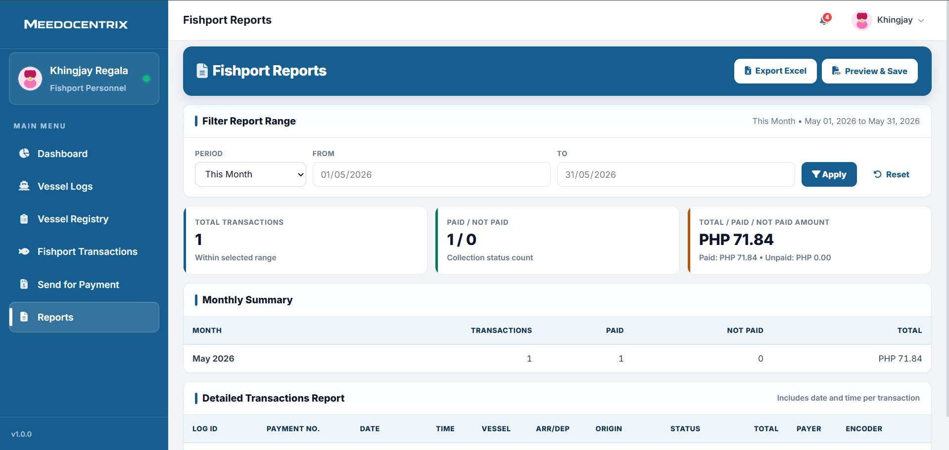
This tab creates Fishport performance reports with totals, paid-versus-not-paid counts, and detailed transaction listings. It supports range filters so reports align with monthly, weekly, or custom review periods. Export and preview tools provide both spreadsheet output and presentation-ready documentation. Functionally, this UI supports management reporting, reconciliation, and transparency of Fishport revenue activity.
Fishport Vessel Logs
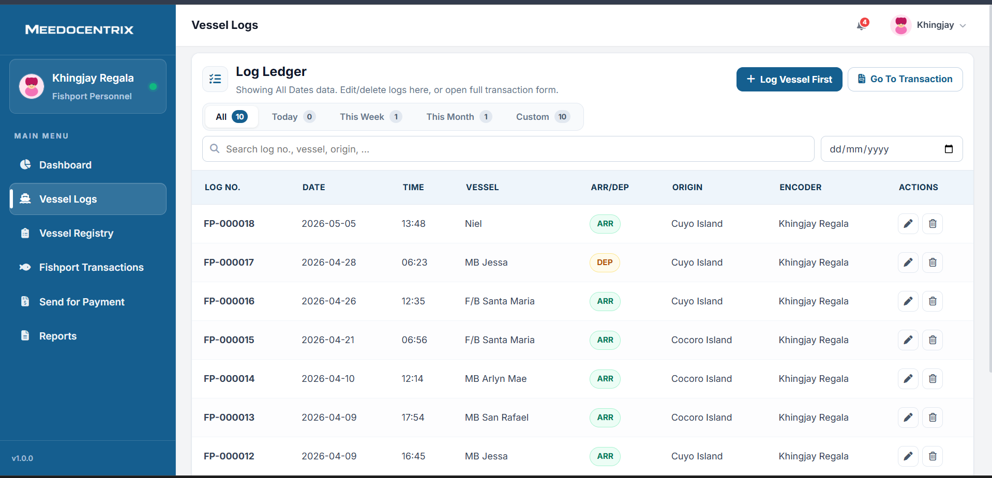
This tab captures and manages vessel movement entries such as arrivals and departures with date, time, origin, and encoder details. It includes quick period filters and search tools so personnel can locate logs without scanning full datasets manually. Action controls allow updates or corrections when operational details change after entry. In system flow, this UI is the operational source record that later drives transaction and payment creation.
Fishport Transactions
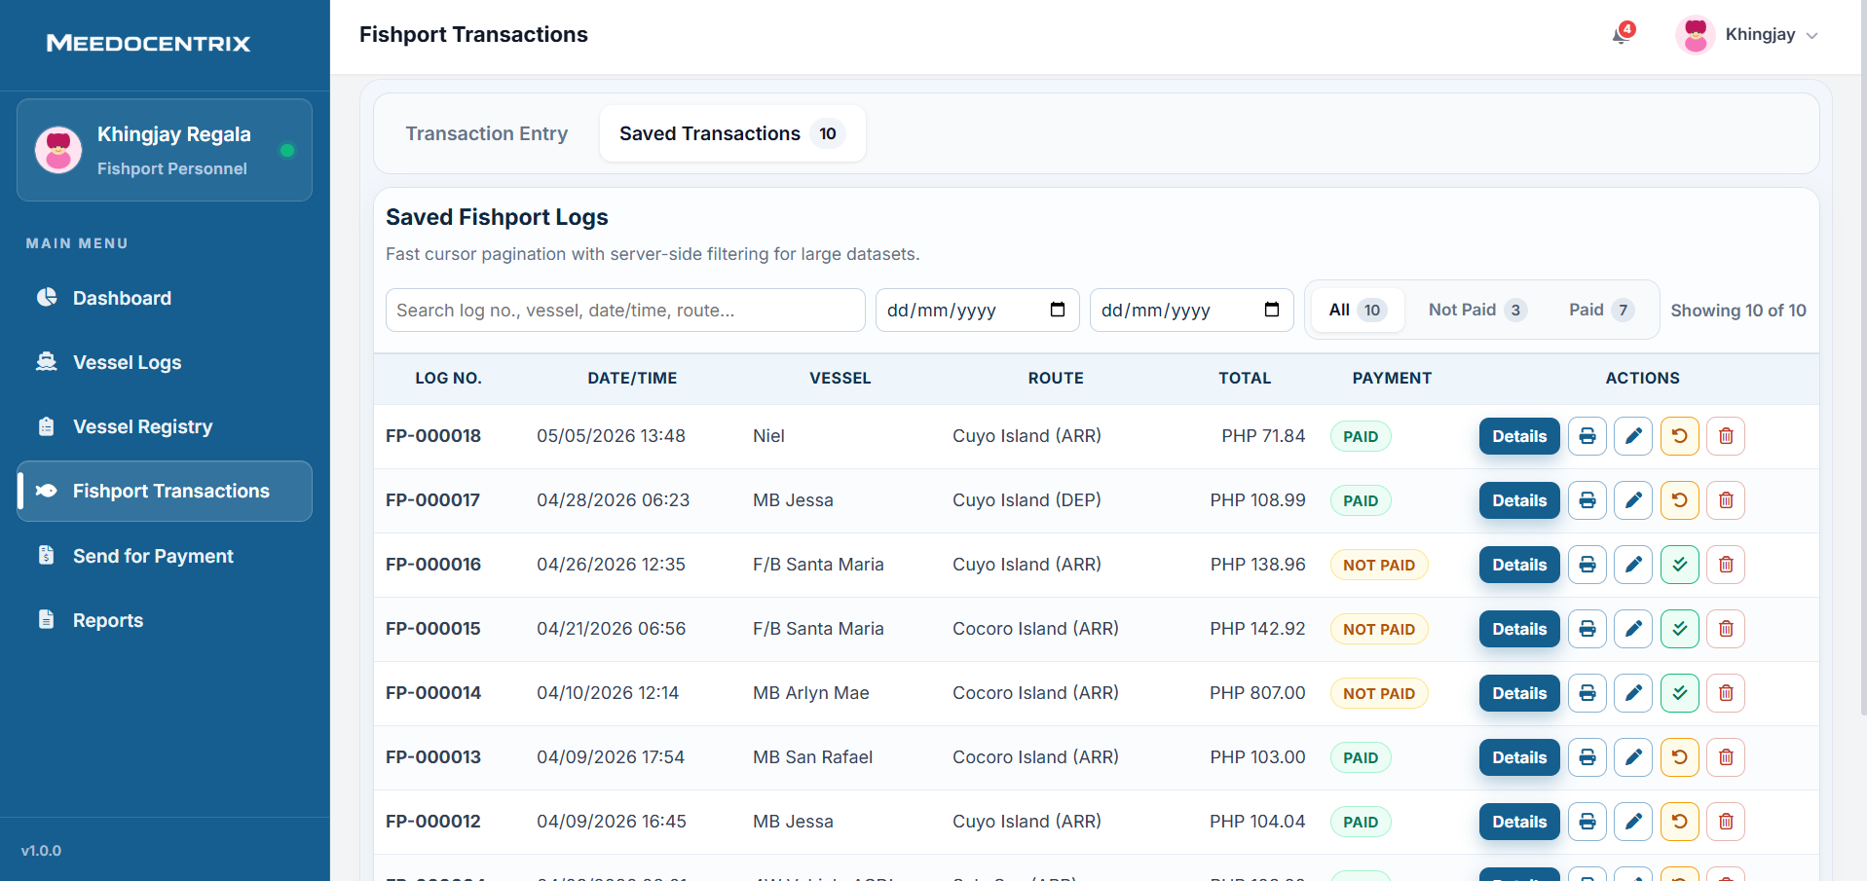
This tab stores generated Fishport billing entries and separates them by payment state for focused follow-up. Users can filter records, inspect log-to-payment links, and use action buttons for details, printing, editing, status updates, or cleanup. The structure supports high-volume server-side browsing so teams can process many records efficiently. Functionally, this UI is the main billing workbench between vessel operations and collection routing.
Fishport Vessel Registry
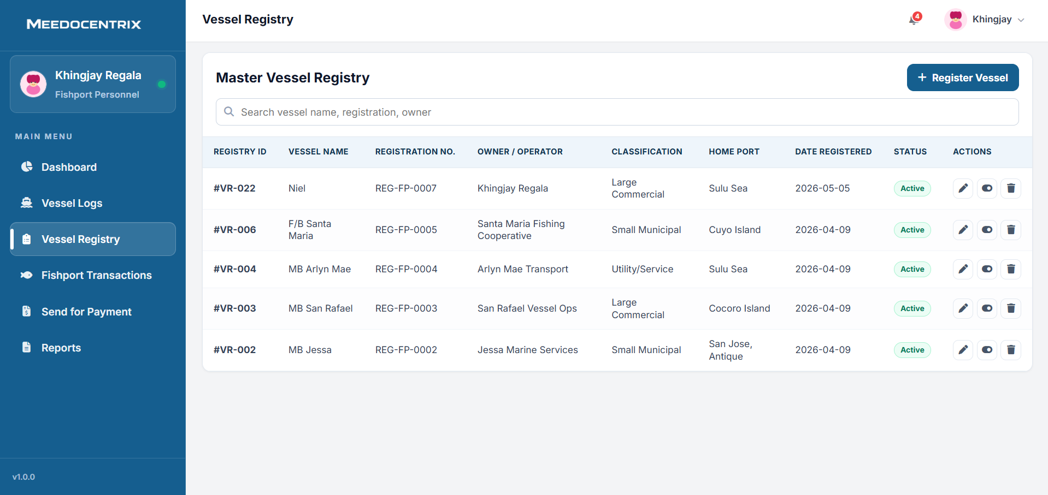
This tab manages the official master list of vessels, including registration number, owner or operator, classification, and home port. Staff can register new vessels and maintain existing records through view and edit actions. Search controls support quick verification when creating transactions or validating vessel identity. Functionally, this UI ensures billing and logs are tied to accurate, traceable vessel profiles.
Market Reports
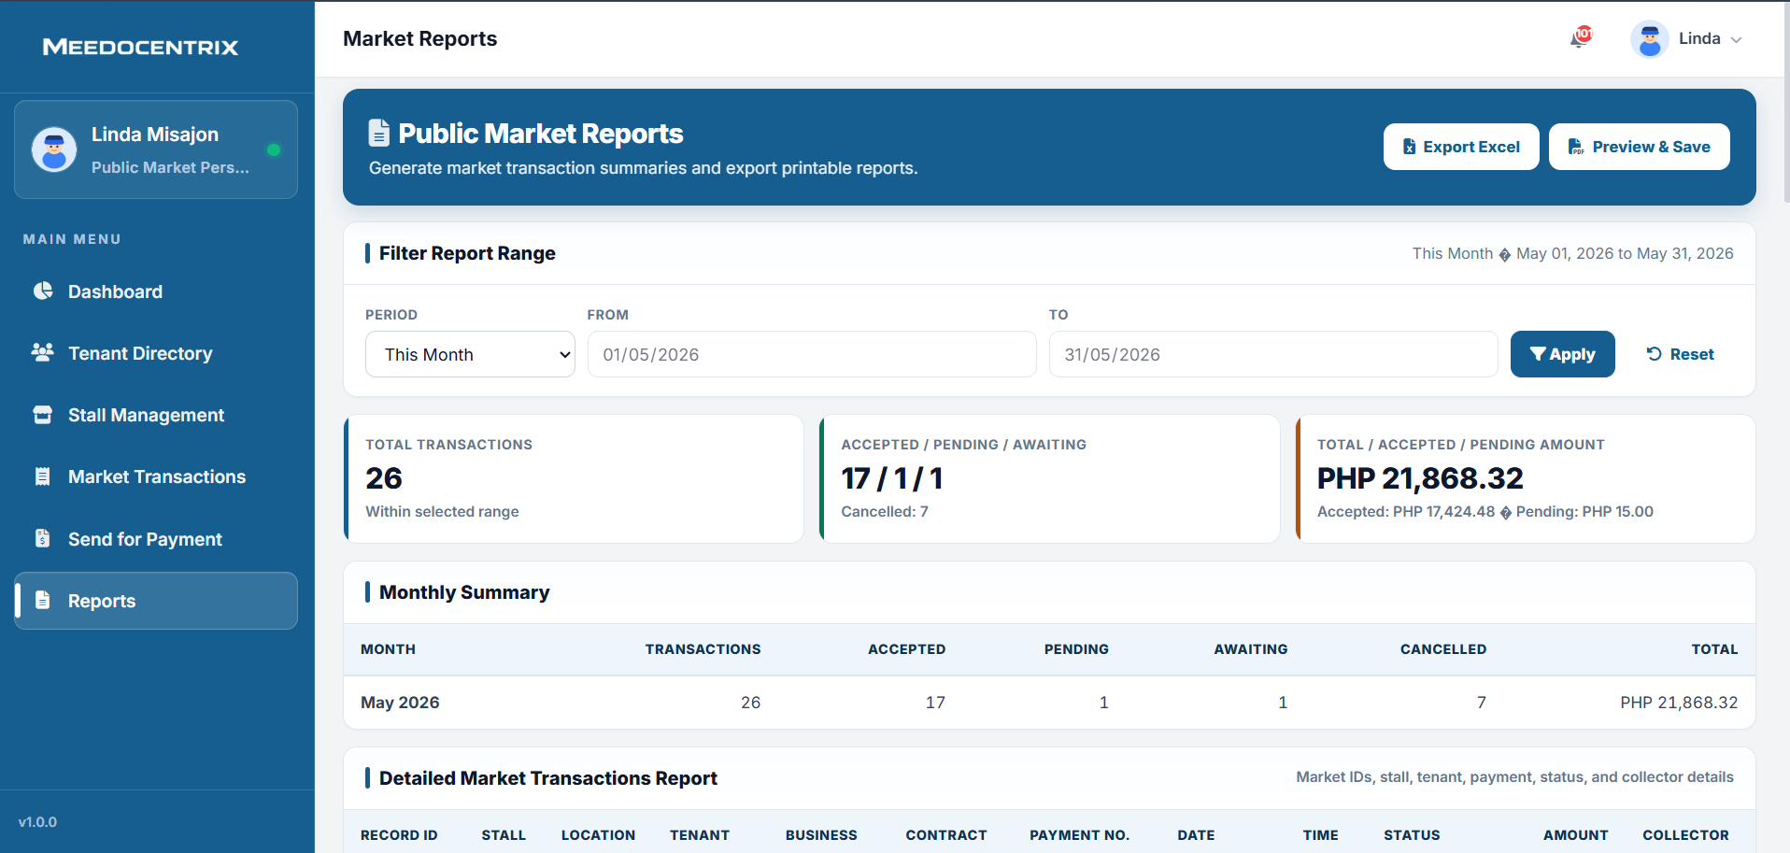
This tab produces Public Market summaries and detailed transaction reports for the selected reporting range. It shows key totals such as transaction counts, status distribution, and accepted or pending amounts before export. The team can preview and save print-ready output or export to spreadsheet format for external analysis. In daily governance, this UI supports transparent reporting for market finance and operational review.
Market Transactions
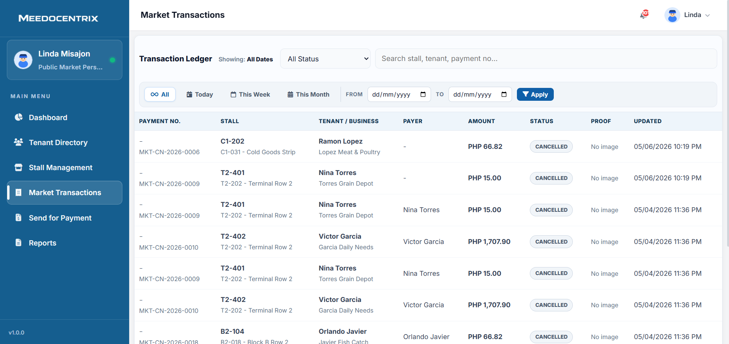
This tab is the market transaction ledger used to review generated payment entries per stall and tenant. It supports status and date filters so staff can isolate paid, pending, cancelled, or other billing outcomes. Each row ties payment number, payer details, amount, proof indicator, and update time for complete transaction tracing. In process terms, this UI is where market billing history is validated before reporting or collection actions.
Market Send for Payment
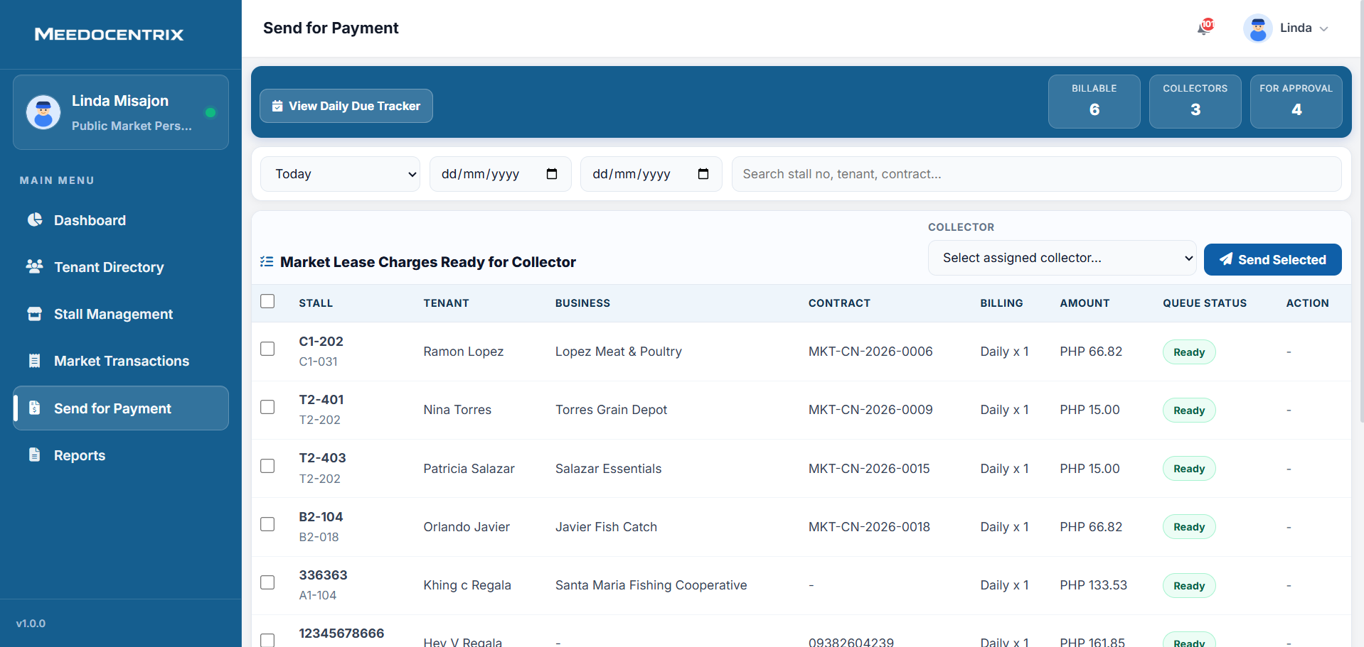
This tab prepares billable market charges and routes selected items to assigned collectors for collection work. Staff can filter by period, review queue-ready records, assign a collector, and send selected entries in batch. The counters at the top summarize billable items, available collectors, and items awaiting approval to guide task planning. Functionally, this UI is the handoff bridge between market billing generation and field collection operations.
Market Tenant Directory
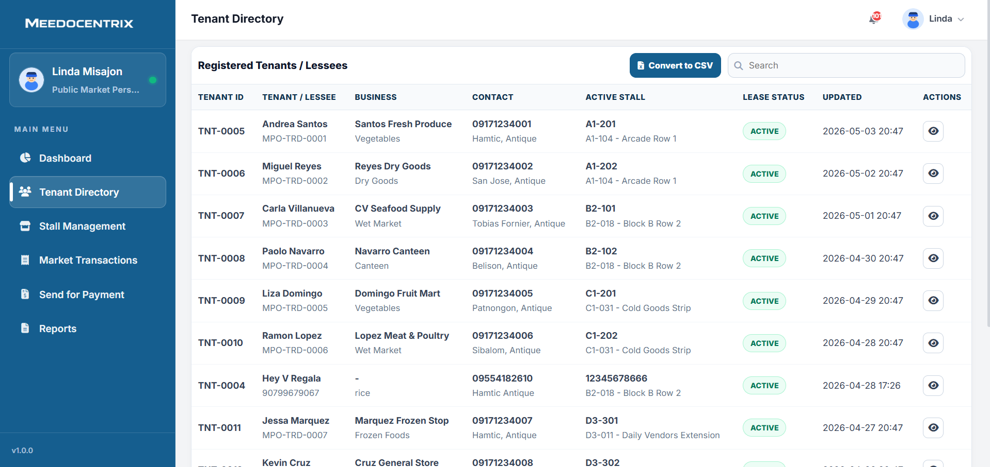
This tab is the official tenant registry for viewing lessee identity, business profile, contact details, and assigned stall information. Search and list controls help staff locate specific tenants quickly during inquiry or validation tasks. The action options are used to open full records for checking lease status and recently updated information. In business flow, this UI keeps tenant records organized so billing and stall management remain accurate.
Market Stall Management
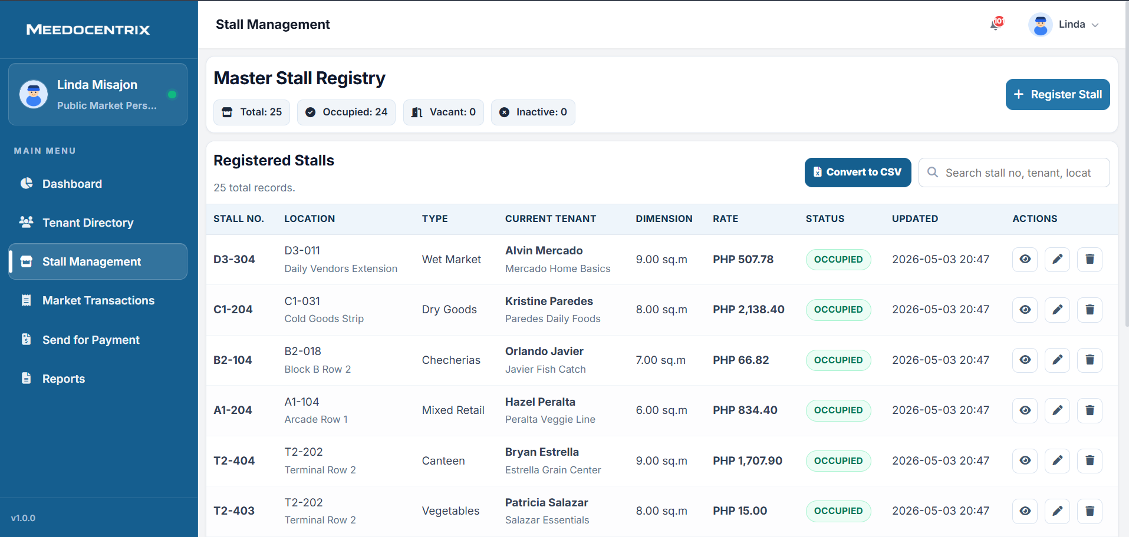
This tab manages the master stall inventory and tracks whether each stall is occupied, vacant, or inactive. Staff can register new stalls, edit stall details, review occupancy links, and maintain rental rate information. The table structure connects location, tenant, stall type, and pricing in one maintainable record set. Operationally, this UI ensures stall allocation and lease charging are based on up-to-date asset data.
Public Market Dashboard
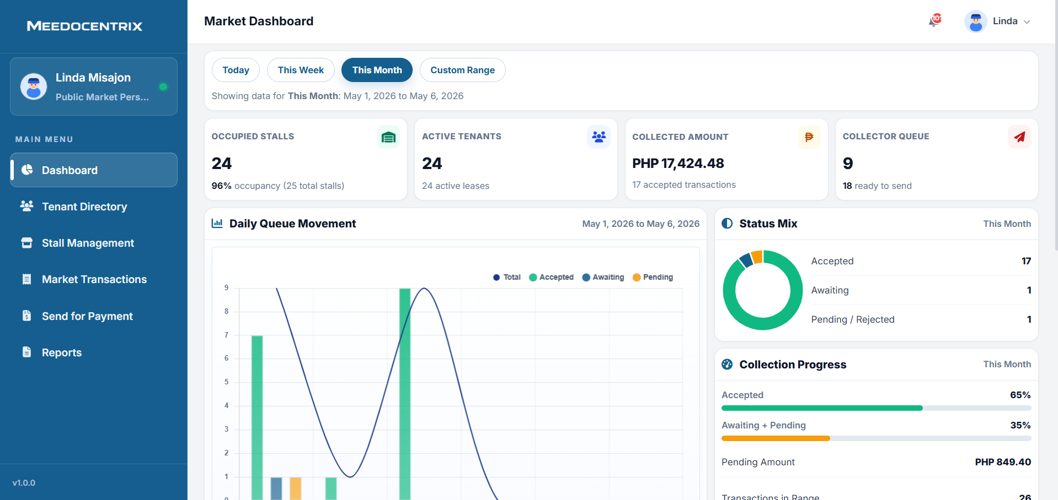
This dashboard gives Public Market personnel a live summary of stall occupancy, active tenants, collected amount, and collector queue status. It includes date-range controls so staff can switch between daily, weekly, monthly, and custom operational windows. Trend and status-mix analytics help the team see payment movement and determine what requires immediate follow-up. In routine use, this screen supports quick planning before sending charges and coordinating collector assignments.

